Canadian Agri-Food Automation
and Intelligence Network (CAAIN)

Technology Development
and
Smart Farm Networks Program

2025 Primary Food Processing Program

PROJECT APPLICATION FORM

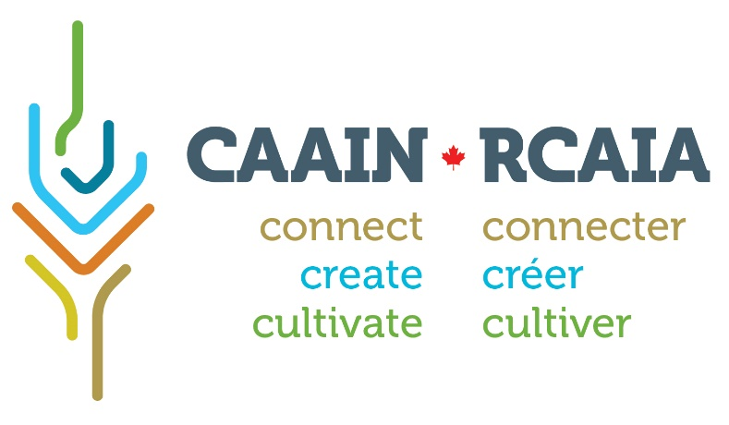

Project Application Form
The Project Application Form (PAF) is intended to facilitate development of applications to CAAIN’s funding programs. The PAF outlines the expectations of project teams and networks and provides context for CAAIN staff to assist applicants in developing a successful proposal. The PAF also allows CAAIN to ensure that proposed activities align with program goals.
Applicants must clearly align their proposals to CAAIN’s priorities for this funding competition. The proposal description should outline the problem to be addressed and the specific objectives and expected outcomes. Applicants should also review the eligibility criteria carefully to ensure that proposals and networks qualify for funding.
A separate PAF must be submitted for each potential network proposal. Successful applicants will be invited to the next stage of the competition. Please note that this is a competitive process. There is no assurance that applicants submitting a PAF will be invited to move onto the next stage or that applicants will be successful at any stage of the competition.

Detailed information about this competition can be found in the Program Guide, available on the CAAIN website: www.caain.ca.
Applicants will be notified by e-mail that their submission has been received.
Completed Project Application Forms must be submitted to info@caain.ca.

APPLICATION
LEAD ORGANIZATION
Organization name: Click here to enter text
LEAD CONTACT
Name: Click here to enter text Position: Click here to enter text
Email: Click here to enter text Telephone: Click here to enter text

TEAM/NETWORK MEMBERS (IN ADDITION TO LEAD APPLICANT)
Please list organizations who will have a significant role in project activities.
(Add more lines as needed)

Project Member: Click here to enter text Contact Person: Click here to enter text
Project Member: Click here to enter text Contact Person: Click here to enter text
Project Member: Click here to enter text Contact Person: Click here to enter text
Project Member: Click here to enter text Contact Person: Click here to enter text
PROJECT TITLE (25-word maximum)
Be as descriptive as possible
Click here to enter text

PROJECT DESCRIPTION (1-page maximum)
Describe the agricultural problem or opportunity to be addressed and what approach(es) this team/network will take in finding a solution. Include the complementary expertise that the members will bring to the network that will ensure its success. Explain how the outcomes of the activities will be demonstrated to end users and the path to widespread adoption of the solution(s). Be sure to include how the project activities will meet the objectives of CAAIN’s Investment in digital agriculture technologies.
Click here to enter text

PROJECT FINANCIALS
(Please note the maximum CAAIN funding available per project is $500,000 CAD)
Estimated Industry cash contribution (60%):
SME #1: Click here to enter text $Click here to enter text
SME #2: Click here to enter text $Click here to enter text
Other: Click here to enter text $Click here to enter text
Estimated CAAIN funding requested (40%): $Click here to enter text
Total Estimated Project Cost: $Click here to enter text
All public and private funding received or applied for must be declared.
Is there any other public funding aligned to this project? ☐ Yes ☐ No
If YES, list the source(s) and amount(s):
Source: Click here to enter text Amount: $Click here to enter text Confirmed? ☐ Yes☐ No
Source: Click here to enter text Amount: $Click here to enter text Confirmed? ☐ Yes☐ No
Source: Click here to enter text Amount: $Click here to enter text Confirmed? ☐ Yes☐ No

CAAIN will match only unencumbered cash contributions to the project for eligible supported expenses. CAAIN will not match:
- Financial contributions from governmental sources (including post-secondary institutions)
- In-kind contributions (however, these are considered to be important indicators of team commitment and likelihood of success. Relevant contributions should be assessed at fair market value.)
- Future revenue associated with the outcomes of the project such as tax incentives associated with the project (e.g. Canadian SR&ED credits)
- The value of shares paid in lieu of cash contributions
- Revenue from sales of the project’s end-products
- Non-eligible contributions (see Appendix 4 of the Program Guide)
However, the presence of these revenue sources may be noted in the application, as the merits of these contributions will be taken into consideration during the evaluation. Applicants must justify the amount of funding requested to CAAIN, whose reviewers may choose to approve the project but award less funding than requested.

LINKAGES TO FOREIGN ECONOMIES
All linkages between program funding recipients and Russia’s economy must be reported. These may include:
- Russian investment or ownership linkages with a recipient, i.e., where Russian nationals and/or business interests may in part or in whole own the recipient business or any of its affiliates
- Russian involvement on boards of directors of recipients
- Recipient business operations in Russia, including branch plants or subsidiaries that are established in Russia
- Close relationships between recipients and Russian entities or companies, including joint ventures, R&D collaborative agreements, or licensing agreements
- Arms-length business relationships between recipients and Russia, including sales or exports to Russia or imports of materials, goods, equipment or services from Russia and filing of patents

DECLARATION
☐ I affirm that to my knowledge everything on this form is true and accurate.
☐ I have read and agree to the network’s commitment to CAAIN regarding IP and Data sharing
☐ I agree to all requirements as outlined above.
☐ I verify all participating project team members agree to CAAIN’s financial due diligence
☐ I am authorized to sign on behalf of the Project Team Lead Organization.
Click here to enter text Click here to enter text
________________________________ ____________________
Name of Project Lead/Primary Contact Date
on behalf of project team/network

________________________________
Signature

